Download Docker CE package and its dependencies:

Download below package on server where internet is accessible:

**wget** [**https://download.docker.com/linux/ubuntu/dists/focal/pool/stable/amd64/docker-ce_20.10.6~3-0~ubuntu-focal_amd64.deb**](https://download.docker.com/linux/ubuntu/dists/focal/pool/stable/amd64/docker-ce_20.10.6~3-0~ubuntu-focal_amd64.deb)

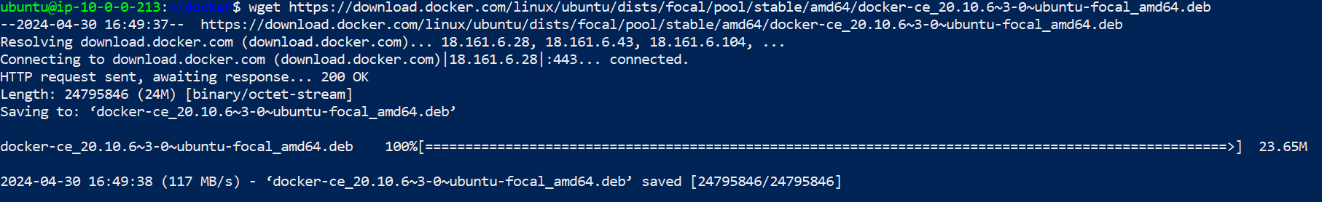

**wget https://download.docker.com/linux/ubuntu/dists/focal/pool/stable/amd64/docker-ce-cli_20.10.6~3-0~ubuntu-focal_amd64.deb**

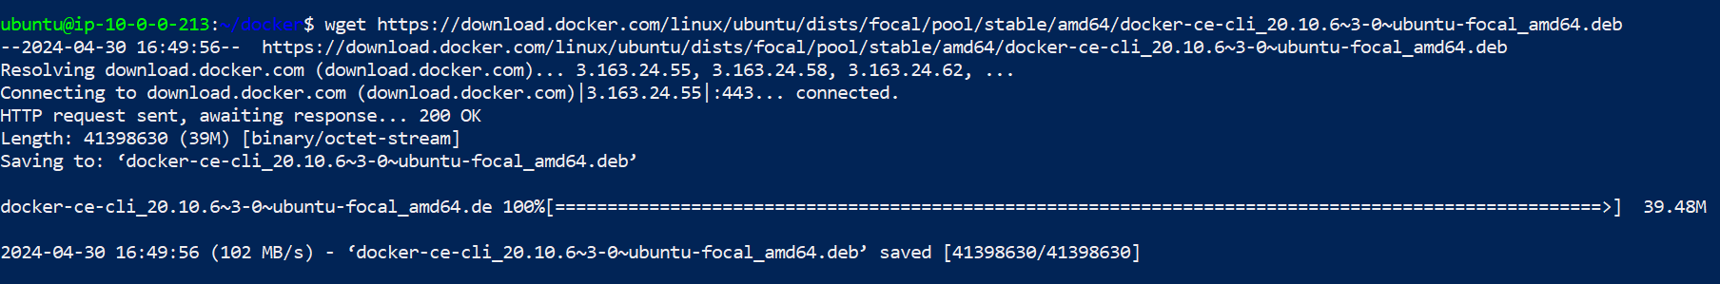

**wget** [**https://download.docker.com/linux/ubuntu/dists/focal/pool/stable/amd64/containerd.io_**](https://download.docker.com/linux/ubuntu/dists/focal/pool/stable/amd64/containerd.io_)**1.4.11-1_amd64.deb**

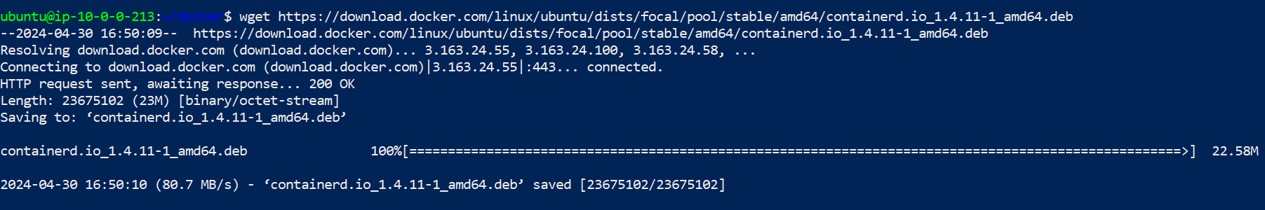

**ls -la**

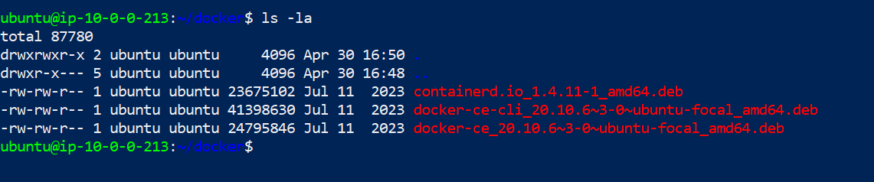

Transfer these packages using SCP to Server where you want to install docker:

**scp -i /home/ubuntu/key.pem containerd.io_1.4.11-1_amd64.deb** [**ubuntu@10.0.1.145:/home/ubuntu/docker**](mailto:ubuntu@10.0.1.145:/home/ubuntu/docker)

**scp -i /home/ubuntu/key.pem docker-ce-cli_20.10.6~3-0~ubuntu-focal_amd64.deb** [**ubuntu@10.0.1.145:/home/ubuntu/docker**](mailto:ubuntu@10.0.1.145:/home/ubuntu/docker)

**scp -i /home/ubuntu/key.pem docker-ce_20.10.6~3-0~ubuntu-focal_amd64.deb** [**ubuntu@10.0.1.145:/home/ubuntu/docker**](mailto:ubuntu@10.0.1.145:/home/ubuntu/docker)

On Server where you want to install docker:

**ls -ls**

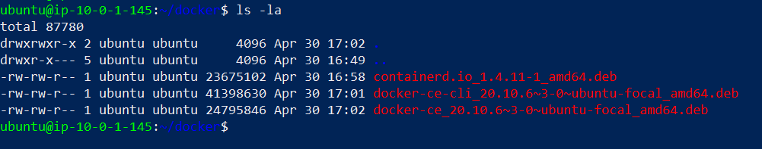

Install containerd.io

**sudo dpkg -i containerd.io_1.4.11-1_amd64.deb**

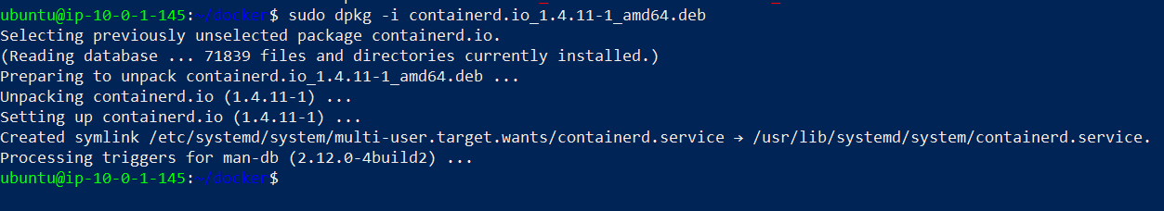

Install docker-ce-cli

**sudo dpkg -i docker-ce-cli_20.10.6~3-0~ubuntu-focal_amd64.deb**

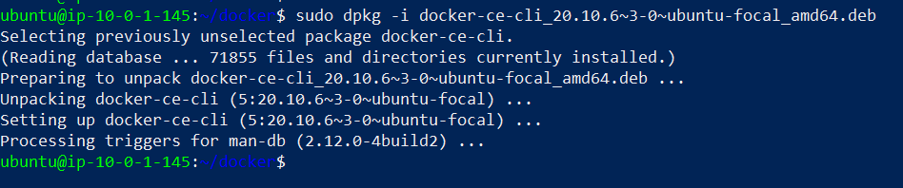

Install Docker CE

**sudo dpkg -i docker-ce_20.10.6~3-0~ubuntu-focal_amd64.deb**

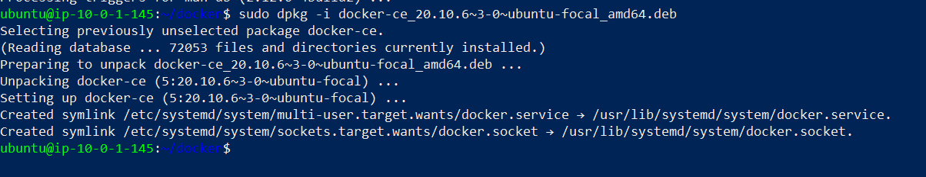

Verify Docker installation

**docker –version**



**Create container on private server**

on server where internet is accessible

pull images

**docker pull httpd**

create tar file

**docker save httpd > httpd_image.tar**

Send tar file on private server

**scp -i /home/ubuntu/key.pem httpd_image.tar** [**ubuntu@10.0.1.132:/home/ubuntu**](mailto:ubuntu@10.0.1.132:/home/ubuntu)

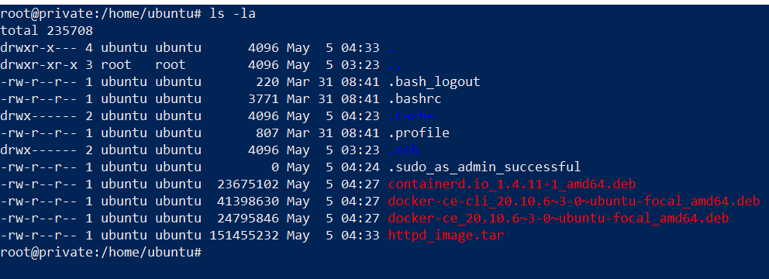

Load image from tar file

**docker load -i httpd_image.tar**

cheack docker images

**docker images**

